Charles Madison

Team Topic:  NBA Statistics

Question #5: How does the home court advantage affect NBA statistics?

The NBA has the widest home-court advantage among the major North American sports, with the home team winning 56-60+ percent of all games in any given season. In the playoffs, it's even more stark, with the home team winning 65 percent of all games since 1984.

During the NBA season each of the 30 teams playing will play 82 games, excluding preseason, all star, and playoffs.  Of these 82 games, 41 are played at home and 41 are played on the road.  If you do the math, and include the games omitted earlier over 1,400 games will be played each year.

**Team Win Percent**

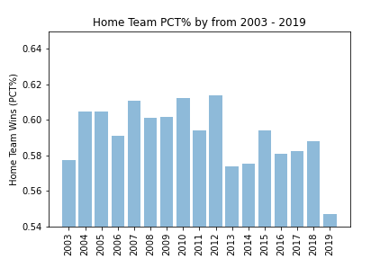

Since 2003 NBA home teams have won an average of 59.2% of all games.  This number has decreased since 2011 where the NBA league had a collective bargaining agreement dispute.  Prior to this time, it was not uncommon for 60-61% winning percentages.

**3PT% Shooting Comparison**

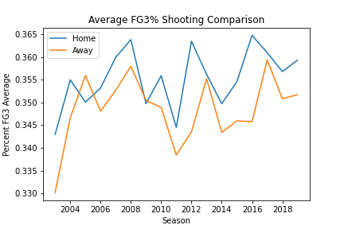

The home court advantage gives NBA teams a slight edge in average 3PT shooting percentages.  Home team shooting average across all seasons has been 35.6% of all 3PT shots taken.  While the away team, on average, has only made about 34.8% of all 3PT shots attempted.

**FT% Shooting Comparison**

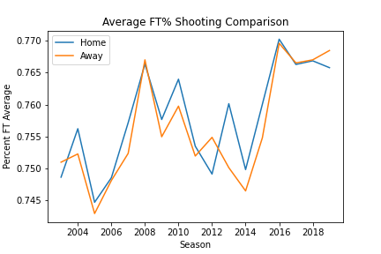

As we turn to shots taken from the Free Throw line, there is no statistical edge for the home team.  As an interesting note, there does not seem to be a corresponding *disadvantage* for the visiting team either.  With home teams scoring an average of 75.8% and visiting teams scoring 75.6% of all Free Throws taken, rowdy home team crowds don’t seem to have any overall effect.

**FT% effect on Home Team Winning %**

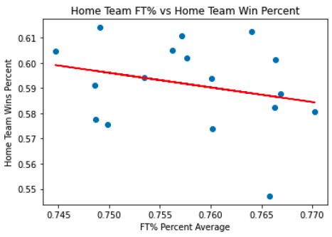

Presented in this scatter plot is a set of data which shows the relationship home team FT% shooting has on percentage of home game wins. Intuitively, you would assume that a home team with great shooter from the line would tend to be more successful. We were surprised to observe that the data suggests a negative include on the percentage of home games won.

**3PT% Shooting affect on Home Team Points**

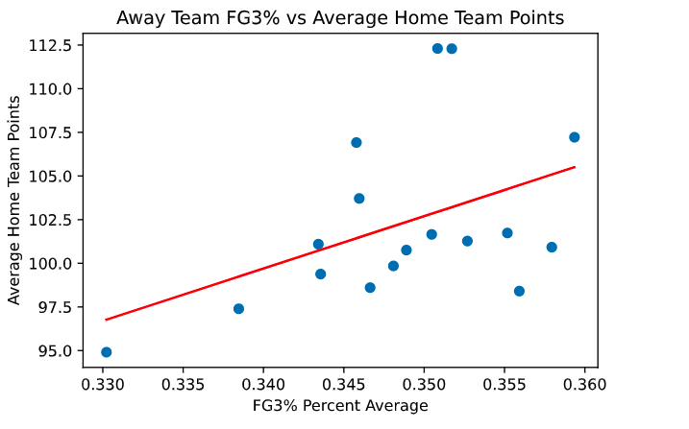

Another interesting relationship piqued our interest. The correlation between the visiting teams’ 3PT shooting average and the home teams average number of points seems to have a positive correlation of 0.449. Or in other words, if a visiting team has a high 3PT shooting average the home team will tend to score more points. Perhaps a visit from Steph Curry to your local club is what is needed to motivate your team to score higher?

**Conclusions**

* A slight winning advantage can be claimed by NBA home teams. They can expect a slighter higher winning percentage over time as compared to away teams, winning about 59% of the time.
* A very thin edge exists between home and away team 3PT shooting. The home team enjoys a 0.7% shooting percentage over the visiting team.
* Surprisingly, no advantage or disadvantage for either team when it comes to FT shooting percentage.
* However, contrary to conventional thought there may be some disadvantages to being a home team.
  + - * As the home team shoots more accurate FTs the result is a tendency to have lower home winning percentage.
      * As the away team shoots more accurate 3PTs the result is a tendency for the home team to score lower average points  (Curry effect?)